Expert Lecture
Academic Year 2021-2022
S.No | Name of the Resource person | Designation and organization | Date organized | Topic covered
1 | Dr. C. Lavanya | Associate Professor, VNR VJIET | 05-08-2021 | Overview of Ground Improvement Technniques in Civil Engineering
2 | Ravikanth Chittiprolu | Managing partner, Nilaya Architects,Structural comnsultant & construction | 23-03-2022 | Enterpreneurship in civil engineering&Awareness on civil engineering software's

Faculty Development Program
A one week Faculty Development Program on “Computer Applications in Civil Engineering” by the Civil Engineering Department was organized during 20th -25th of September 2021. This FDP helped the faculty members to acquire knowledge related to application of Civil Engineering software in different specializations of Civil Engineering such as structural engineering, Geotechnical engineering, Water resources engineering, transportation engineering etc It was also helpful in enhancing application of various Civil Engineering software in various organizations like planning level, design level and execution level. It was successful with participants from national level.
Graduation Day
The Twelfth and Thirteenth Graduation Day of the college was organized on Saturday 9 th October 2021 PM. Graduation ceremony was conducted for the batches 2020 and 2021 passed out students. The Chief Guest for the occasion was Mr. Srinivas Ramsagar, Vice President, Software Engineering, United Health Group. Batch toppers were honored on this occasion.
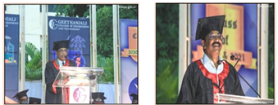

Orientation program:
The Orientation Day for the newly admitted B. Tech. students of the Academic Year 2021-22 was organized on 26th November, 2021. Sri Lakshmikanth Reddy Basani, Software Consultant Engineer, Sri Seshu Kumar Gudepu, General manager, Wipro Technologies and Sri Murali Tenneti, Vice President, FICO, were the Guests of Honor on this occasion.

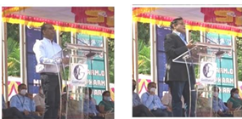

Alumni Meet

The 9th Alumni Meet of the institution was organized on 25th December 2021. 163 alumni of various batches attended the meet.

